**Week 2 Report**

**Block Diagram**

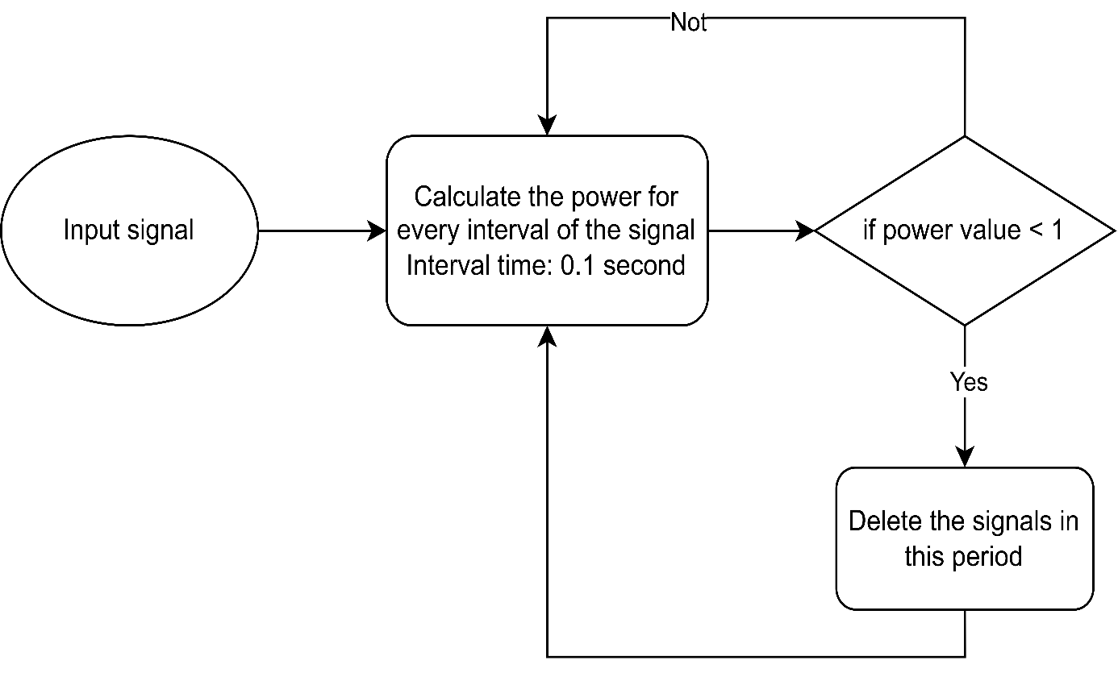

**OBJECTIVE**

To define a threshold value, to identify the noise.

* Defining a threshold helps us to have a reference value to isolate useful information from noise.
* In a real-life scenario, audio collected via Tiva are stored in a buffer of finite size and we can’t wait to detect the signal until the buffer is full.
* So, we measure the data at an interval before the buffer gets full and compare it with silence power in order to detect noise.

**SIMULATION IN MATLAB**

Step 1: Read the data

Step 2 :

Calculate the power for every 0.1s of the signal:

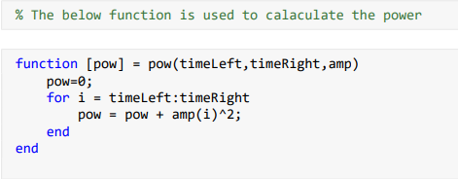

Step 3:

Assume the power of silent room = 10

If the calculated power < 10,

We delete the audio at that interval

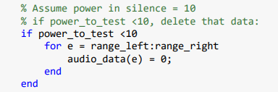

**OUTPUT**

At the end of the process, we get a filtered audio, which contains only the useful sound.